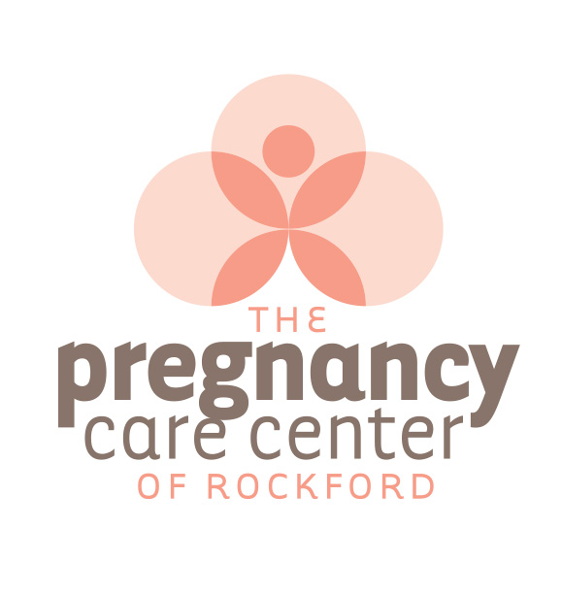
What About Abortion?

A few thoughts before viewing this video…

At the Pregnancy Care Center of Rockford, we want to be known for what we stand for and not what we are against. We are FOR the LIFE of both our client and the baby she is carrying.

However, because at least half of our clients are considering or leaning towards abortion as an option in their decision making process, our receptionists, mentors, class facilitators, and nurses must have a foundational knowledge of what abortion procedures involve as well as the potential risks and consequences. Sharing this information appropriately in love ensures that our clients can make a fully informed decision.

To reiterate, we never seek to use this information to scare or manipulate a woman into making the decision we believe she should make. The challenging tension we walk in this role is to share truthful information gently and lovingly and allow the Holy Spirit to work in the heart of the client. When clients see a strong bias in our center with which they may disagree, their emotional walls go up and they no longer view this as a safe place where they can deal openly and honestly with the options they are considering. Walls don’t serve anyone well.

This video seeks to give honest, accurate and thorough answers to medical and psychological questions about abortion. Many followers of Christ approach the topic of abortion from a spiritual and moral perspective, which is natural and foundational. However, most of our clients are not coming with that already established moral foundation, so spiritual and moral arguments are typically ineffective and even detrimental to helping a woman choose life. This video is helpful in that regard because it contains an interview of a medical doctor and a psychotherapist to address the physical and emotional impact of abortion. Clients are generally open to this information because it has a direct impact on them.

This video is approximately 20 minutes and while it contains no graphic images, it is not easy to listen to the explanation of what various abortion procedures entail. If for any reason, you prefer not to watch this video alone and wish to watch it with a staff member from The Pregnancy Care Center, we would be happy to view it and process the content together.

Reflection Questions:

- Do you understand the differences between the various abortion surgical and medical procedures used during different trimesters? What questions do you have regarding these procedures?

____________________________________________________________________________________

____________________________________________________________________________________

____________________________________________________________________________________

- What are the physical and emotional risks a woman faces if she chooses abortion?

____________________________________________________________________________________

____________________________________________________________________________________

____________________________________________________________________________________

____________________________________________________________________________________

- By the age of 45, one in three women will have had an abortion. If emotional reactions to the trauma of abortion are often delayed and involve deep guilt, shame, rejection, depression and regret, what kind of posture (attitude, tone of voice, demeanor) would be most appropriate for a volunteer working with a client?

____________________________________________________________________________________

____________________________________________________________________________________

____________________________________________________________________________________

- At The Pregnancy Care Center, we talk a lot about “helpful” and “harmful” language to use with clients. The doctor in this video makes 25 references to the “baby,” 8 references to “killing the baby” or “dead fetus.” Would you classify this as helpful or harmful language to use with a client? Does this kind of verbiage show bias? If so, what alternatives could be used in its place?

_____________________________________________________________________________________

_____________________________________________________________________________________

_____________________________________________________________________________________

- What other questions, concerns or issues would you like to discuss with a staff member regarding abortion in general or our approach to talking about abortion with clients?

_____________________________________________________________________________________

_____________________________________________________________________________________

